

Alba Márquez Rodríguez

Changes

Online Videogames Store Database

Database System Engineering – Computer Science

The project consists on an Online Videogames Store Database

Professor: Krystian Wojtkiewicz



Contents

Changes 2

List of Applications views 3

Main Login Screen 3

Register 3

Main Screen 3

Show Personal User information 3

Edit Personal User information 3

See Offers 3

Filtered Offers 3

Show Game Information 3

Add Review 3

Show payment information 4

Interface State Diagram 5

Mock-up for each interface view 6

Main Login Screen 6

Register 6

Main Screen 6

See Personal Information 7

Edit Personal Information 7

See Offers 7

Filtered Offers 8

Show game information 8

Reviews 9

Add Review 9

Continue Buying/ Pay 9

Show Payment Information 10

Add Payment Method 10

Implemented Views 11

Login 11

Main Screen 11

See Personal Information 11

Edit Personal Information 12

See Offers 12

Filtered Offers 12

Game Information 13

# Changes

Changes will be marked with a yellow high-light

The explanation of the changes will be marked with this style

# List of Applications views

## Main Login Screen

Data:

* User login information (email and password from Contact table)

## Register

Data:

* User personal information -> Contact table, Address Table

## Main Screen

* Game information -> Game
* Game offers information -> Game, GameSpecialOffer, GameOffer
* User personal information -> Contact table

## Show Personal User information

Data:

* User personal information -> Contact table, Address table

## Edit Personal User information

Data:

* User personal information -> Contact table, Address table

It was not stated on the previous version an Edit Personal User Information but it was contemplated on the diagram.

## See Offers

Data:

* Game information -> Game
* Game offers information -> Game, GameSpecialOffer, GameOffer

It was not stated on the previous version a See Offers View but it was necessary for the Application implementation as it is one of the most important views.

## Filtered Offers

Data:

* Game information -> Game
* Game offers information -> Game, GameSpecialOffer, GameOffer

## Show Game Information

Data:

* Game information -> Game
* Game AudioVisuals -> GameAudivisuals, GamePhoto, GameVideo
* Other Game’s Saga -> Saga
* Game Review’s -> GameReview

## Add Review

Data:

* Game Review’s -> GameReview

## Show payment information

Data:

* Personal User Information -> Contact
* Order -> SalesOrderHeader, SalesOrderDetail
* CreditCard -> ContactCreditCard, CreditCard, CardType

# Interface State Diagram

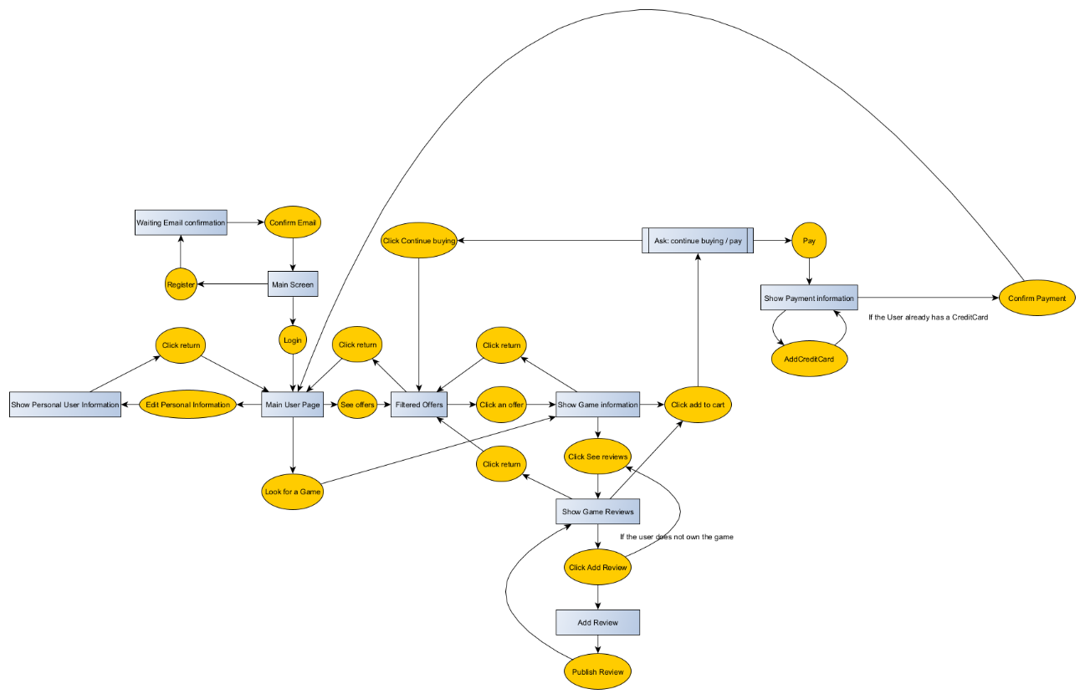

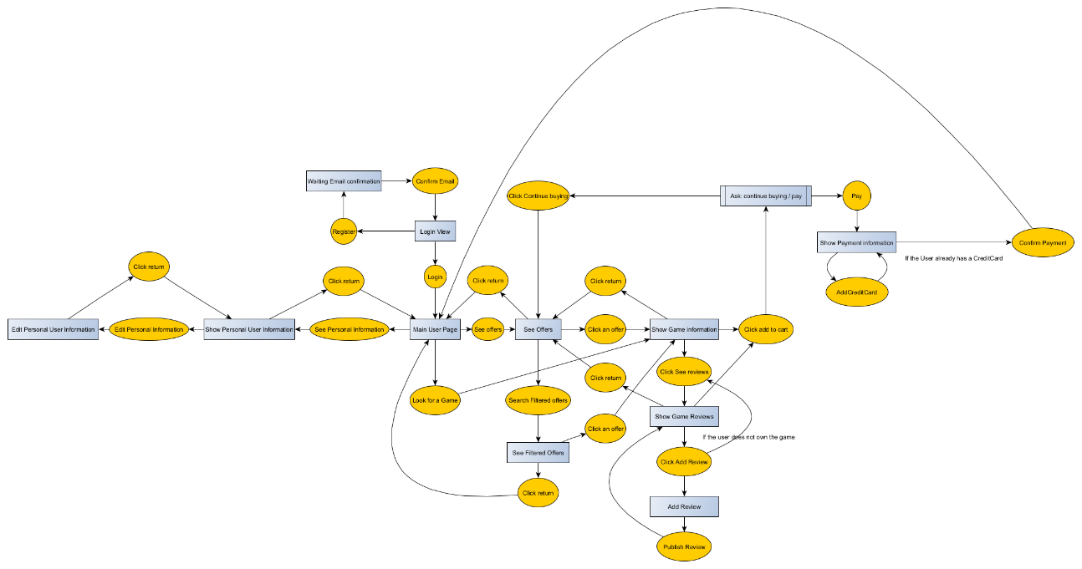

Some views contemplated on the previous version but not added to the diagram and as an Application view has been added such us Edit Personal Information.

During the implementation I was aware of the facility of first looking for an offer instead of directly looking for a filtered offer. So a previous step to see filtered offers was added. From both, See Offers and See Filtered Offers you can access Game Information.

Top image corresponds to the old diagram while the bottom one corresponds to the current version.

# Mock-up for each interface view

## Main Login Screen

## Register

## Main Screen

## Graphical user interface Description automatically generatedSee Personal Information

It has been added a button to edit the personal information

## Edit Personal Information

It was not considered on the previous version so it has been added

## See Offers

See Offers was not shown on the previous version of the project and it has been added.

## Filtered Offers

It has been added a jTable for showing the information

## Graphical user interface, text, application, email Description automatically generatedGraphical user interface, text, application Description automatically generatedShow game information

It has been added a Jtable to show the information as it was easier to show it in a table instead of changing the fields of every jTextField. Also a buttom to See Game Reviews has been added because from the Game Information View we should access the game reviews but in the previous version it was not possible to do it.

## Reviews

## Add Review

## Continue Buying/ Pay

## Show Payment Information

## Add Payment Method

# Implemented Views

## Login

## Main Screen

## See Personal Information

## Edit Personal Information

## See Offers

## Filtered Offers

## Game Information

